A000-US-Engravings-19th c

Case 12

[1598 (1631) Theodor De Bry Print AZTEC HUNTING RITUALS](http://www.ebay.com/itm/252305216684?_trksid=p2057872.m2749.l2649&ssPageName=STRK%3AMEBIDX%3AIT)

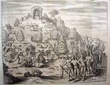

**Natives of Florida - Lebigre-Duquesne 1859**

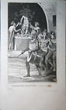

**Natives of Virginia - Lebigre-Duquesne 1859**

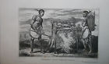

**Natives of Virginia - Lebigre-Duquesne 1859**